

Darshan University

A Project Report on

**“Auction Management System”**

Under the subject

**Software Engineering (2301CS405)**

B. Tech, Semester – IV

Computer Science & Engineering Department

Submitted By

Student Name: Manav Kotecha Enrollment No.:23010101145

Academic Year (2024-2025)

|  |  |
| --- | --- |
| Internal Guide  Prof. R. B. Gondaliya  Darshan University | Dean-DIET  Dr. Gopi Sanghani  Darshan University |

**Computer Science & Engineering**

**Department**

**Darshan University**

**DECLARATION**

We hereby declare that the SRS, submitted along with the **Software Engineering** **(2301CS405)** for entitled **“Auction Management System”** submitted in partial fulfilment for the Semester-5 of **Bachelor Technology (B. Tech)** in **Computer Science and Engineering (CSE)** Departmentto Darshan University, Rajkot, is a record of the work carried out at **Darshan University, Rajkot** under the supervision of R. B. Gondaliya and that no part of any of report has been directly copied from any students’ reports, without providing due reference.

Manav Kotecha

M.A.K

Student’s Signature

Date: __________

**Computer Science & Engineering**

**Department**

**Darshan University**

**CERTIFICATE**

This is to certify that the SRS on **“Auction Management System” has** been satisfactorily prepared by **Manav Kotecha (23010101145)** under my guidance in the fulfillment of the course **Software Engineering (2301CS405)** work during the academic year 2024-2025.

Internal Guide Dean-DIET

Prof. R. B. Gondaliya Dr. Gopi Sanghani

Darshan University Darshan University

**ACKNOWLEDGEMENT**

I wish to express my sincere gratitude to my project guide Prof. R. B. Gondaliyaand all the faculty members for helping me through my project by giving me the necessary suggestions and advices along with their valuable co- ordination in completing this work.

I also thank my parents, friends and all the members of the family for their precious support and encouragement which they had provided in completion of my work. In addition to that, I would also like to mention the Darshan University personals who gave me the permission to use and experience the valuable resources required for the project from the University premises.

Thus, in conclusion to the above said, I once again thank the faculties and members of **Darshan University** for their valuable support in completion of the project.

Thanking You

**Manav Kotecha**

**ABSTRACT**

The **Auction Management System** is designed to develop a computerized platform that simplifies and automates the management of auction processes. This system acts as a tool to transition traditional auction practices into a modern, digital format. The project includes features that go beyond basic auction management , such as user registration, secure login, real-time bidding, and comprehensive auction tracking.

The system provides separate modules for participants and administrators. Participants can register, browse auction listings, place bids, and monitor their bidding status. The platform also includes features such as instant notifications, bid history, and secure payment processing. Additionally, users can request specific items to be included in upcoming auctions through a request form.

The admin module allows auction organizers to crud the entire system. Admins can add, update, or remove auction items, set bidding rules, monitor ongoing auctions, and handle user disputes. The system can also generate detailed reports, including auction performance reports, user participation reports, and revenue summaries.

The primary purpose of this system is to reduce manual efforts, enhance accessibility, and ensure a secure, efficient, and transparent auction experience. It is designed to cater to a wide range of industries, including art, real estate, automobiles, and more, while delivering a user-friendly and scalable solution.

**Table of Contents**

List of Figures ....................................................................................................................................................... I

List of Tables ....................................................................................................................................................... II

1 Introduction 1

1.1 Product perspective 1

1.2 Product features 1

1.3 Functional Requirement 1

**1.2.1 Admin**: 1

**1.2.2 Buyer** 2

1.4 Non-Functional Requirement 2

**1.4.1** Usability: 2

**1.4.2** Accuracy: 2

**1.4.3** Availability: 2

**1.4.4** Maintainability: 3

2 Design and Implementation Constraints 4

2.1 Use case diagram 4

2.2 Activity diagram and Swimlane diagram 5

2.3 Sequence diagram 8

2.4 State diagram 9

2.5 Class diagram 10

2.6 Data flow diagram 11

**2.6.1** Context diagram (level-0) 11

**2.6.2** DFD Level-1 11

**2.6.3** DFD Level-2 12

3 External interface requirement (Screens) 13

3.1 Screen-1: Registration Form 13

3.2 Screen-2: Login Form 14

3.3 Screen-3: Add borrower book 15

4 Database design 16

4.1 List of Tables 16

5 Stories and Scenario 17

5.1 Story-1: Add New Book in Library Catalogue 17

**5.1.1** Scenario# S1.1 17

**5.1.2** Scenario# S1.2 17

**5.1.3** Scenario# S1.3 17

5.2 Story-2: Search Book 18

5.3 Story-3: Crud due date for borrowed book 18

5.4 Story-4: Renew book 18

5.5 Story-5: Generate a report on book usage and availability 18

6 Test cases 19

7 References 23

**List of Figures**

Figure 2.1-1 Usecase Diagram for Auction Management System...................................................................... 4

Figure 2.2-1 Activity Diagram for Buyer ............................................................................................................. 5

Figure 2.2-2 Activity Diagram for Admin ............................................................................................................ 6

Figure 2.2-3 Swimlane Diagram for Buyer ......................................................................................................... 7

Figure 2.3-1 Sequence diagram for Book Issue .................................................................................................. 8

Figure 2.4-1 State diagram of Book .................................................................................................................... 9

Figure 2.4-2 State diagram for Librarian ........................................................................................................... 9

Figure 2.5-1 Class diagram for Library management system ........................................................................... 10

Figure 2.6-1 Context diagram for Library management system ...................................................................... 11

Figure 2.6-2 DFD level-1 for Library management system ............................................................................... 11

Figure 2.6-3 DFD level-2 for Issue book ........................................................................................................... 12

Figure 3.1-1 Screen-1: Registration Form ........................................................................................................ 13

Figure 3.2-1 Screen-2: Login Form ................................................................................................................... 14

Figure 3.3-1 Screen-3: Add borrower book ...................................................................................................... 15

**I**

**List of Tables**

Table 3.1-1 Screen element of Registration form ............................................................................................ 13

Table 3.2-1 Screen element of Login form ....................................................................................................... 14

Table 3.3-1 Screen element of Add borrower book ......................................................................................... 15

Table 4.1-1 Table: Book .................................................................................................................................... 16

Table 4.1-2 Table: Borrower ............................................................................................................................. 16

Table 4.1-3 Table: Staff ..................................................................................................................................... 16

Table 4.1-4 Table: Student ............................................................................................................................... 16

**II**

# 1 Introduction

## 1.1 Product perspective

This product is designed to handle the essential functions of an auction, including item cataloging, bid monitoring, user management , and report generation. It is particularly suitable for industries such as art, real estate, automobiles, and collectibles, while being scalable for larger or smaller auction events.

## 1.2 Product features

**1.2.1 Who can use this system**:

* **Auctioneer** – The administrator who is responsible for managing the auctions.
* **Bidder** – Participates in auctions by placing bids on available items.
* **Guest** – Can browse auctions.

**1.2.2 Features for the Auctioneer:**

* Add, update, or delete auction listings.
* Set auction parameters like starting bid, reserve price, auction duration.
* View and crud bids placed on items in real-time.
* Approve or reject user registrations.
* View bidder details.
* Send notifications to users about new auctions, updates, or alerts.
* Generate auction performance reports, revenue summaries, and user participation details.
* Ensure secure transactions.

**1.2.3 Features for the Bidder:**

* Register and log in to the system.
* View and update personal information.
* Show active auctions by category.
* Place bids on items.
* Receive notifications about bid status.
* View bid history .
* Submit requests for specific items to be included in future auctions.

**1.2.4 Features for the Guest:**

* Show available auctions and item details.

## 1.3 Functional Requirement

### **1.3.1 Admin**:

* **Add Auction Item:** Admin can add new items for auction by entering all required details into the system.
* **Update Auction Item:** Admin can modify the details of existing auction items.
* **Delete Auction Item:** Admin can remove any incorrect auction item from the system.
* **User Management :** Admin can crud user accounts.
* **Auction Monitoring:** Admin can monitor ongoing auctions and review bidding activities in real-time.
* **Set Auction Parameters:** Admin can define rules like minimum bid increments, auction start and end times, and reserve prices.
* **Reports and Analytic:** Admin can generate detailed reports on auction performance, user activity, and revenue.
* **Search Functionality:** Admin can search for auction items.
* **Set User Permissions:** Admin can assign roles or permissions to users, categorizing them as buyers, sellers.
* **Notification Management :** Admin can send updates or alerts to users about auctions, changes, or reminders.

### **1.2.2 Buyer**

* **Authentication:** Buyers must authenticate using a username and password before accessing the system.
* **Browse Auctions:** Buyers can browse active auctions with filters like item category or base price.
* **Place Bids:** Buyers can place bids on items and monitor bid status in real-time.
* **Bid History:** Buyers can view their bidding history, including won and lost auctions.
* **Search Auction Items:** Buyers can search for specific auction items using keywords, categories, or other criteria.
* **Notifications:** Buyers receive notifications for important updates.
* **Payment:** Buyers can complete payments for won auctions through secure payment .
* **Account Management :** Buyers can view and update their account details, such as personal information and payment methods.

**1.2.3**  **Seller**

* **Authentication:** Sellers must log in using their credentials to access their account.
* **Add Auction Item:** Sellers can add items for auction by entering details like item description and base price.
* **Update Auction Item:** Sellers can modify the details of their items, such as description or base price, before the auction begins.
* **Remove Auction Item:** Sellers can cancel or remove an item from the auction list.
* **View Bidding Activity:** Sellers can monitor bids placed on their items in real-time.
* **Set Auction Parameters:** Sellers can define auction rules for their items including minimum bid increments.
* **Search Functionality:** Sellers can search their listed items or auction history .
* **View Reports:** Sellers can access performance reports for their auctioned items, including total bids and final selling price.
* **Notifications:** Sellers receive updates about auction status, bids received, and payment confirmations.
* **Payment Management :** Sellers can view and crud payment records for their sold items.

## 1.4 Non-Functional Requirement

### **1.4.1** Usability:

• The UI should be simple enough for everyone to understand and get the relevant information without any special training. Different languages can be provided based on the requirements.

### **1.4.2** Accuracy:

• The data stored about the books and the fines calculated should be correct, consistent, and reliable.

### **1.4.3** Availability:

• The System should be available for the duration when the library operates and must be recovered within an hour or less if it fails. The system should respond to the requests within two seconds or less.

### **1.4.4** Maintainability:

• The software should be easily maintainable and adding new features and making changes to the software must be as simple as possible. In addition to this, the software must also be portable.

# 2 Design and Implementation Constraints

## 2.1 Use case diagram

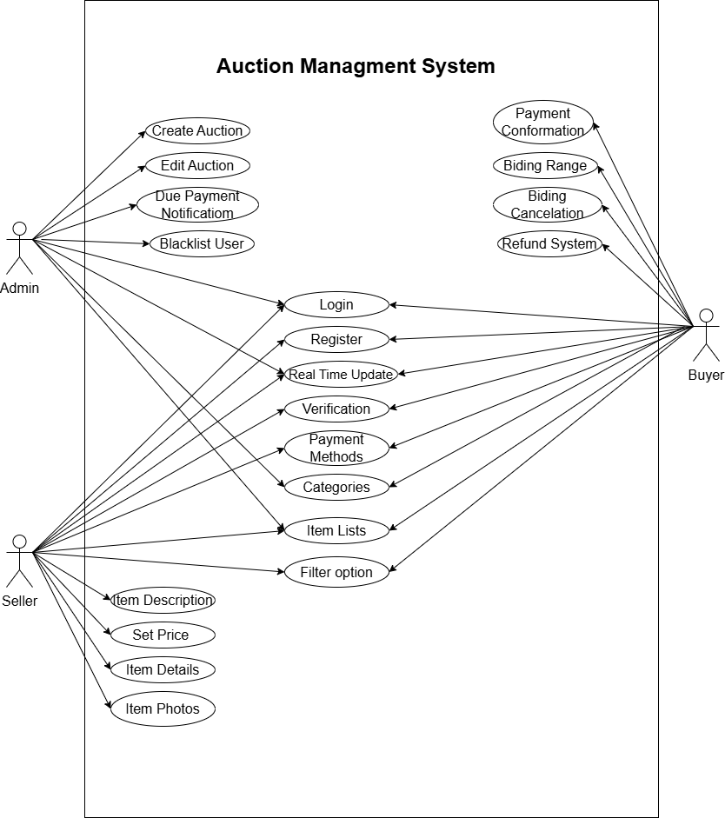

*Figure 2.1-1 Usecase Diagram for Auction Management System*

## 2.2 Activity diagram and Swimlane diagram

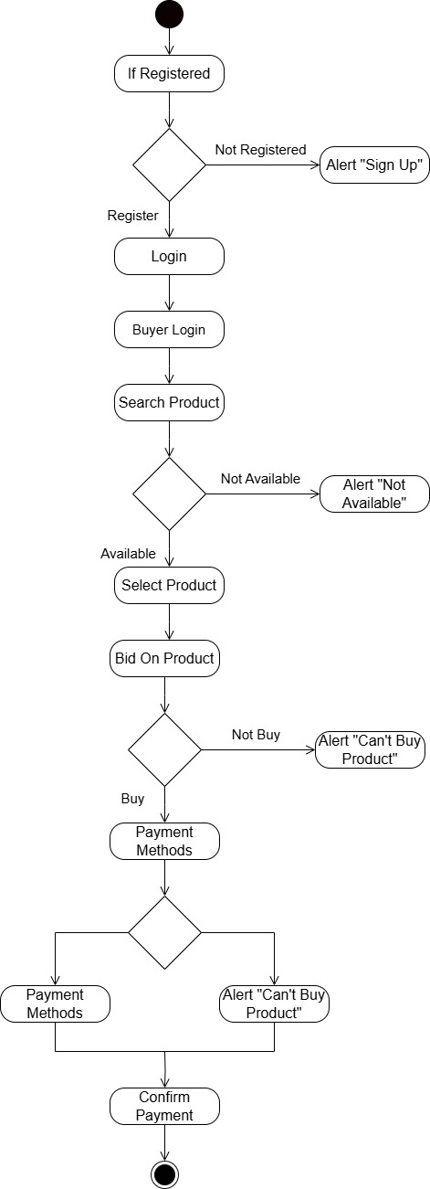

*Figure 2.2-1 Activity Diagram for Buyer*

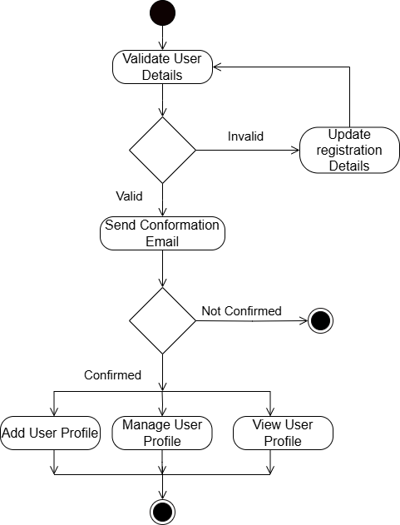

*Figure 2.2-2 Activity Diagram for Admin*

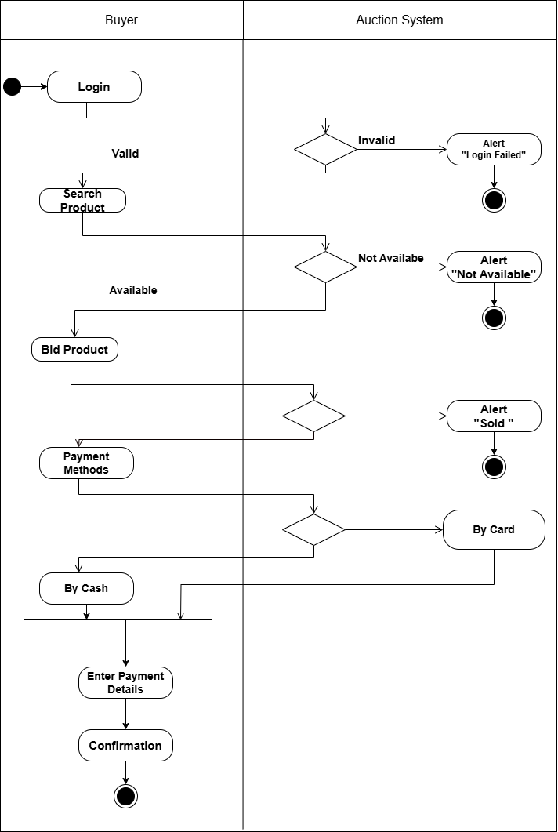

*Figure 2.2-3 Swimlane Diagram for Buyer*

## 2.3 Sequence diagram

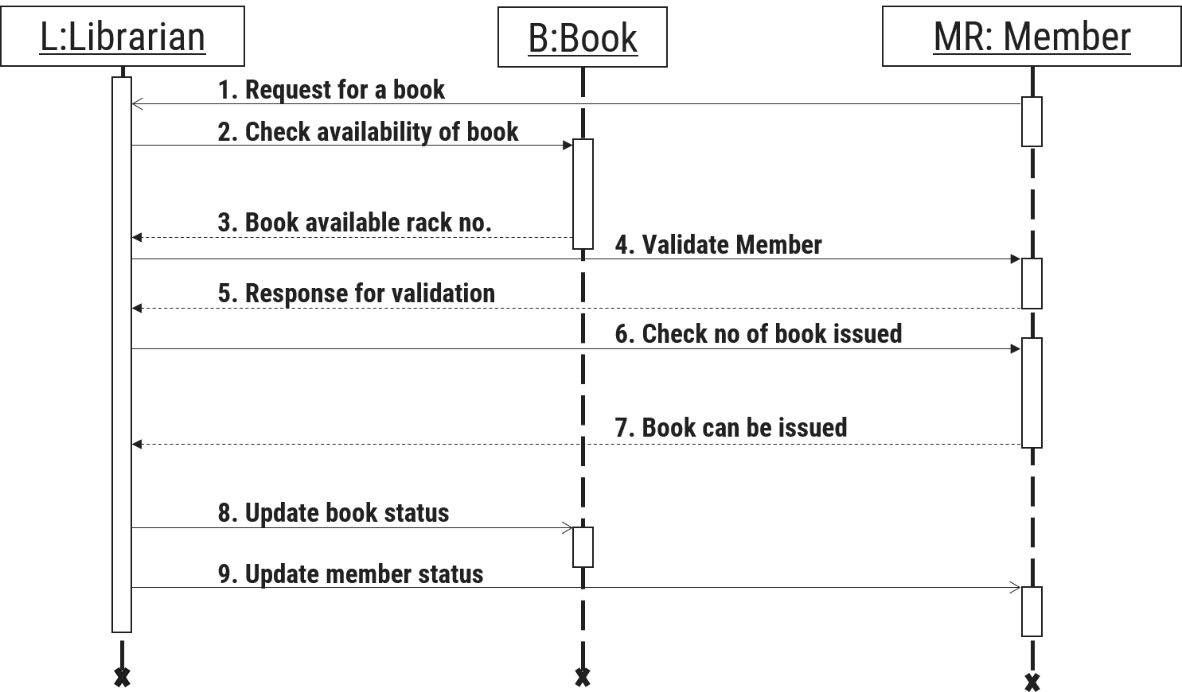

*Figure 2.3-1 Sequence diagram for Book Issue*

## 2.4 State diagram

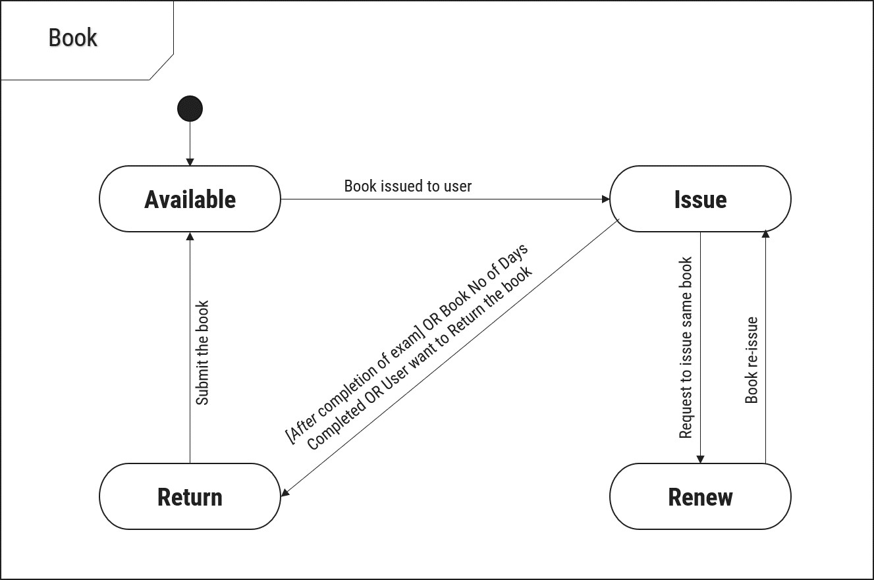

*Figure 2.4-1 State diagram of Book*

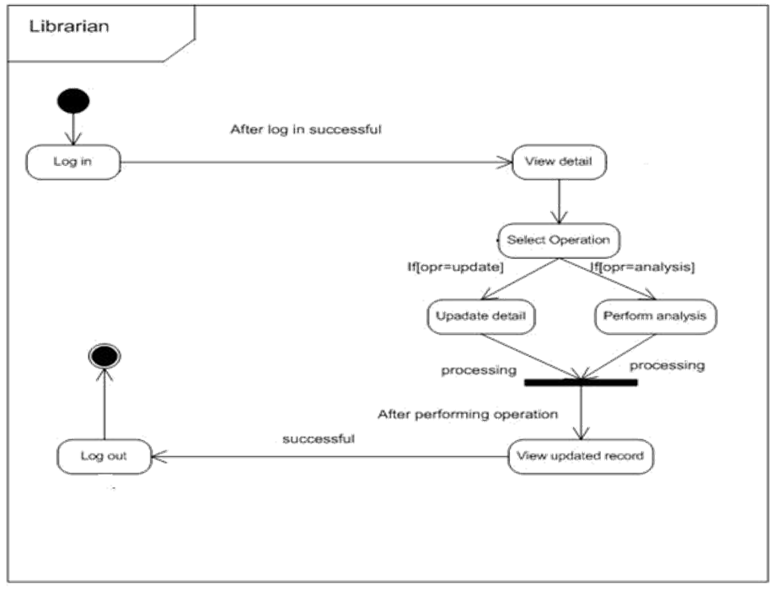

*Figure 2.4-2 State diagram for Librarian*

## 2.5 Class diagram

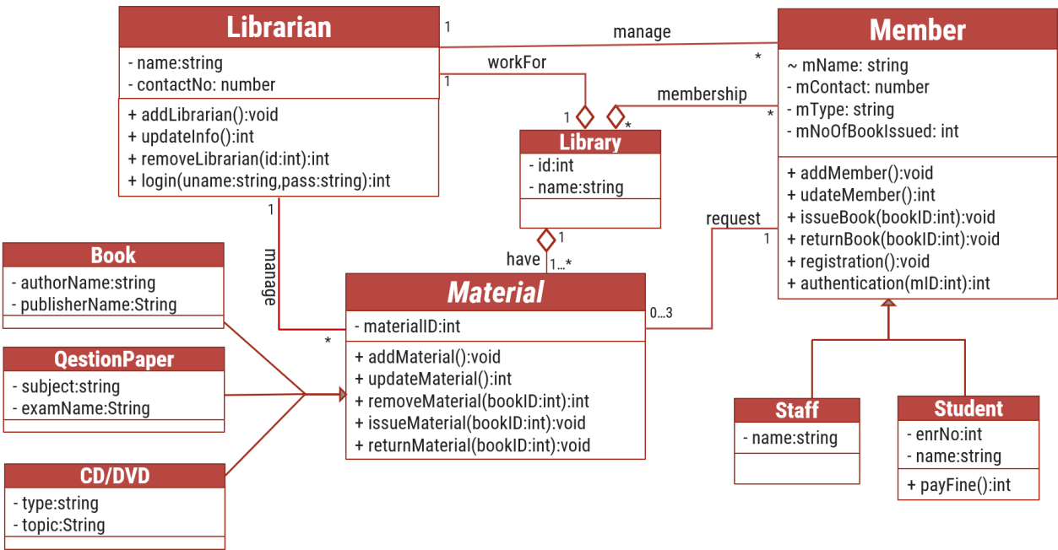

*Figure 2.5-1 Class diagram for Library management system*

## 2.6 Data flow diagram

### **2.6.1** Context diagram (level-0)

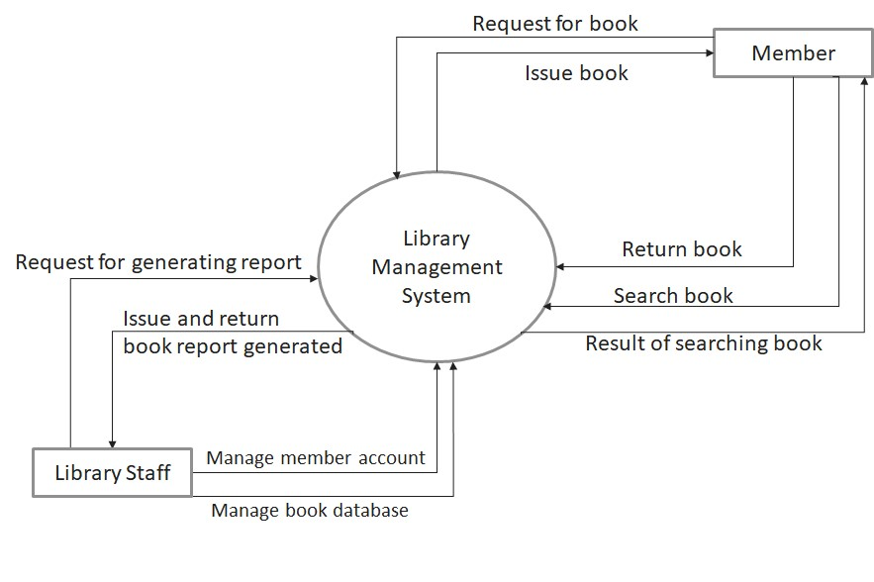

*Figure 2.6-1 Context diagram for Library management system*

### **2.6.2** DFD Level-1

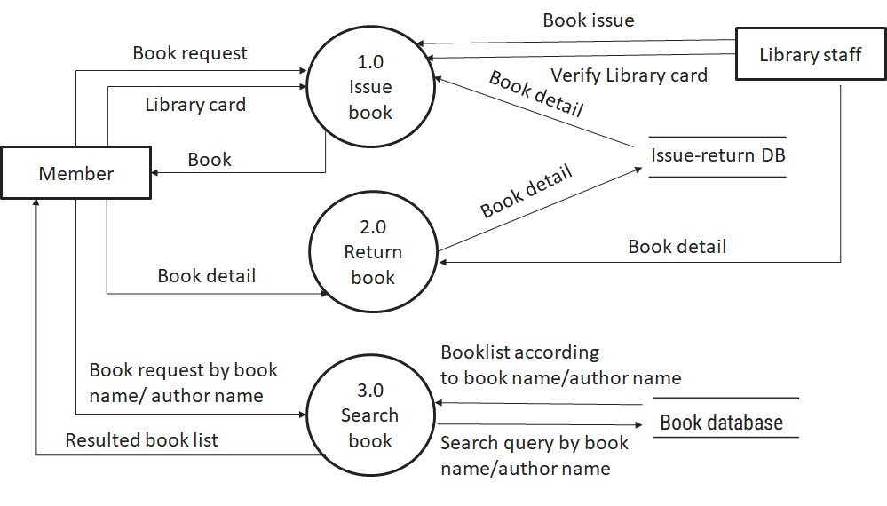

*Figure 2.6-2 DFD level-1 for Library management system*

### **2.6.3** DFD Level-2

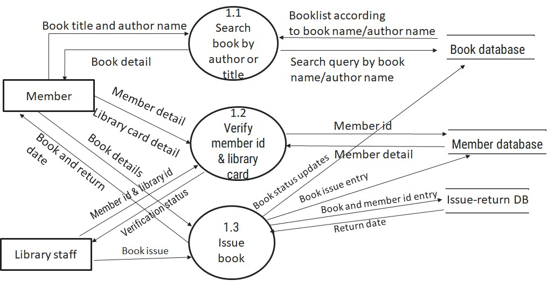

*Figure 2.6-3 DFD level-2 for Issue book*

# 3 External interface requirement (Screens)

## 3.1 Screen-1: Registration Form

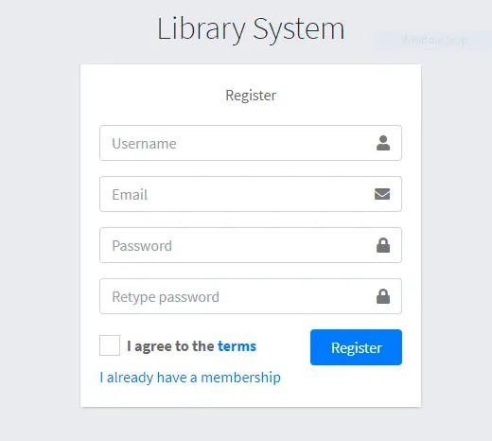

*Figure 3.1-1 Screen-1: Registration Form*

**Purpose:** This form will allow the target end-users to register in the system. To register , the following information will be encoded in the system.

*Table 3.1-1 Screen element of Registration form*

|  |  |  |  |  |  |
| --- | --- | --- | --- | --- | --- |
| **Sr.** | **Screen Element** | **Input Type** | **O/M** | **1/N** | **Description** |
| **1** | Username | Textbox | M | 1 | Username field should be editable and accept the Username. |
| **2** | Email | Textbox | M | 1 | Email field should be editable and accept the email with proper format. |
| **3** | Password | Password | M | 1 | Password field should be editable and accept the password and display as star or dot. |
| **4** | Retype password | Password | M | 1 | Retype Password field should be editable and accept the password and display as star or dot. |
| **5** | I agree to the terms | Checkbox | M | 1 | Checkbox for accepting terms and condition. |
| **6** | I already have a membership | Link | ------ | ------ | Link for navigate to login page for registered user. |
| **7** | Register | Button | ------ | ------ | Register is a button for store the entered data into database. |

## 3.2 Screen-2: Login Form

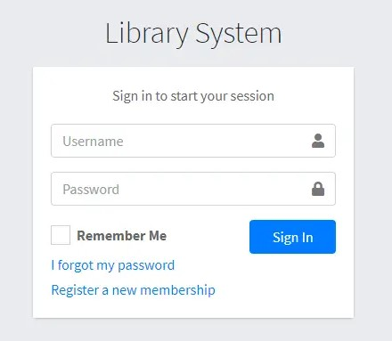

*Figure 3.2-1 Screen-2: Login Form*

**Purpose:** This form will be used by the system’s users to access records and features of the system. The users will input the correct combination of their username and password to be able to login to the system.

*Table 3.2-1 Screen element of Login form*

|  |  |  |  |  |  |
| --- | --- | --- | --- | --- | --- |
| **Sr.** | **Screen Element** | **Input Type** | **O/M** | **1/N** | **Description** |
| **1** | Username | Textbox | M | 1 | Username field should be editable and accept the Username. |
| **2** | Password | Password | M | 1 | Password field should be editable and accept the password and display as star or dot. |
| **3** | Remember Me | Checkbox | M | 1 | Saving login credentials through remember me checkbox |
| **4** | I forgot my  password | Link | ------ | ------ | Link for navigate to Forgot password page for allows users to recover password. |
| **5** | Register a new membership | Link | ------ | ------ | Link for navigate to membership registration. |
| **6** | Sign in | Button | ------ | ------ | Login button navigates to another page even if valid login credentials. |

## 3.3 Screen-3: Add borrower book

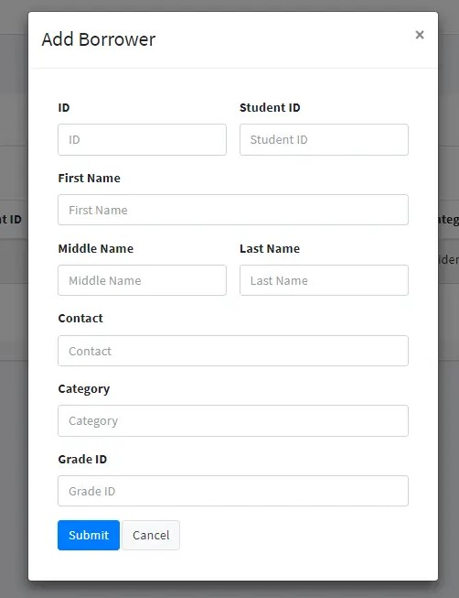

*Figure 3.3-1 Screen-3: Add borrower book*

**Purpose:** This module will allow the system administrator to add, edit, update or delete borrowers of book. The admin can add borrower information and crud it.

*Table 3.3-1 Screen element of Add borrower book*

|  |  |  |  |  |  |
| --- | --- | --- | --- | --- | --- |
| **Sr.** | **Screen Element** | **Input Type** | **O/M** | **1/N** | **Description** |
| **1** | Borrower ID | Textbox | M | 1 | Borrower ID field should be editable and fill autogenerated Borrower ID. |
| **2** | Student ID | Textbox | M | 1 | Student ID field should be editable and accept Student barcode id. |
| **3** | First Name | Textbox | M | 1 | First Name field should be editable and accept only string as a borrower first name. |
| **4** | Middle Name | Textbox | O | 1 | Middle Name field should be editable and accept only string as a borrower middle name. |
| **5** | Last Name | Textbox | M | 1 | Last Name field should be editable and accept only string as a borrower last name. |
| **6** | Contact | Textbox | M | 1 | Contact field should be editable and accept only 10-digit mobile number. |
| **7** | Grade Id | Textbox | O | 1 | Auto fetch detail from the database if proper student id is entered. |
| **8** | Submit | Button | ----- | ----- | Submit is a button for store the entered data into database. |
| **9** | Cancel | Button | ----- | ----- | Cancel is a button for close add borrower dialog. |

# 4 Database design

## 4.1 List of Tables

• Users

• Item

• Bids

• Categories

• Payments

*Table 4.1-1 Table: Users*

|  |  |  |  |  |
| --- | --- | --- | --- | --- |
| **Column** | **Data Type** | **Null** | **Keys & Constrains** | **Default Value & Description** |
| **Userid** | int | NN | PK (Auto Increment) |  |
| **UserName** | varchar(100) | NN |  |  |
| **Password** | varchar(50) | NN |  |  |
| **Email** | varchar(50) | NN |  |  |
| **ContactNumber** | int | NN |  |  |
| **Address** | varchar(50) | AN |  |  |

*Table 4.1-2 Table: Items*

|  |  |  |  |  |
| --- | --- | --- | --- | --- |
| **Column** | **Data Type** | **Null** | **Keys & Constrains** | **Default Value & Description** |
| **ItemId** | int | NN | PK (Auto Increment) |  |
| **ItemName** | varchar(100) | NN |  | Reference of Book Table |
| **Title** | varchar(50) | AN |  |  |
| **Description** | varchar(100) | NN |  |  |
| **StartingPrice** | Int | NN |  |  |
| **StartDate** | DateTime | NN |  | Reference of Student and  Staff Table |
| **EndDate** | DateTime | AN |  |  |
| **CategoryId** | int | AN | FK | Referncing of Category Table |

*Table 4.1-3 Table: Bids*

|  |  |  |  |  |
| --- | --- | --- | --- | --- |
| **Column** | **Data Type** | **Null** | **Keys & Constrains** | **Default Value & Description** |
| **BidID** | int | NN | PK (Auto Increment) |  |
| **ItemID** | int | NN | FK | Referncing of Item Table |
| **UserID** | int | NN | FK | Referncing of User Table |
| **BidAmmount** | Int | NN |  |  |
| **BidStart** | DateTime | AN |  |  |

*Table 4.1-4 Table: Categories*

|  |  |  |  |  |
| --- | --- | --- | --- | --- |
| **Column** | **Data Type** | **Null** | **Keys & Constrains** | **Default Value & Description** |
| **CategoryID** | int | NN | PK (Auto Increment) |  |
| **CategoryName** | varchar(100) | NN |  |  |
| **Description** | varchar(100) | AN |  |  |

*Table 4.1-4 Table: Payments*

|  |  |  |  |  |
| --- | --- | --- | --- | --- |
| **Column** | **Data Type** | **Null** | **Keys & Constrains** | **Default Value & Description** |
| **PaymentID** | int | NN | PK (Auto Increment) |  |
| **UserId** | int | NN | FK | Referencing of Users Table |
| **ItemId** | int | NN | FK | Referencing of Items Table |
| **PaymentAmount** | int | NN |  |  |
| **PaymentDate** | DateTime | NN |  |  |
| **PaymentMethod** | varchar(50) | AN |  |  |

# 5 Stories and Scenario

## 5.1 Story-1: Add New Book in Library Catalogue

|  |  |  |
| --- | --- | --- |
| *Story #* ***S1*** | **:** | **As a** Librarian,  **I want to** add a new book in library catalogue  **So that** everyone can easily find and borrow it. |
| **Priority** | **:** | High |
| **Estimate** | **:** | XL |
| **Reason** | **:** | The addition of a new book to the library catalogue is crucial for ensuring that the library's collection is up-to-date and accessible to everyone. |

### **5.1.1** Scenario# S1.1

|  |  |  |
| --- | --- | --- |
| *Scenario#* ***S1.1*** | **:** | Adding a New Book with Valid Information |
| **Prerequisite** | **:** | Librarian is logged in to the Library management system. |
| **Acceptance**  **Criteria** | **:** | **Given:**  The Librarian is navigated to the library catalog management page. Valid book information, including title, author, ISBN, and other relevant details is added.  **When:**  The librarian selects the "Add New Book" option  And The librarian enters valid book details  The librarian clicks the "Save" button to add the book to the catalog.    **Then t**he system successfully adds the book to the catalog and the librarian receives a confirmation message with the book's identification number. |

### **5.1.2** Scenario# S1.2

|  |  |  |
| --- | --- | --- |
| *Scenario#* ***S1.2*** | **:** | Adding a New Book with Invalid Information. |
| **Prerequisite** | **:** | The librarian is logged into the library management system. |
| **Acceptance**  **Criteria** | **:** | **Given:** The librarian is on the library catalogue management page  **When:** The librarian selects the "Add New Book" option and the librarian enters an incomplete or incorrect book details and librarian clicks the "Save" button to add the book to the catalogue.  **Then t**he system displays error messages for the incorrect or missing information and the book is not added to the catalogue. |

### **5.1.3** Scenario# S1.3

|  |  |  |
| --- | --- | --- |
| *Scenario#* ***S1.3*** | **:** | Attempting to Add a Duplicate Book |
| **Prerequisite** | **:** | The librarian is logged into the library management system and the librarian is on the library catalogue management page |
| **Acceptance**  **Criteria** | **:** | **Given**: The book information, including title, author, ISBN, and other relevant details, is available and the book with the same ISBN is already in the catalogue.  **When**: User Clicks on “Add book” button. Enter a number of copies with the same book detail mentioned in the field. |
|  | | **Then**: Generate unique book id, barcode and spine label for various book of same title. |

## 5.2 Story-2: Search Book

|  |  |  |
| --- | --- | --- |
| *Story #* ***S2*** | : | **As a** Librarian or member,  **I want to** search for books by title, author, or keyword,  **So that** I can quickly find books that match my interests. |
| **Priority** | **:** | High |
| **Estimate** | **:** | M |
| **Reason** | **:** | Implementing a search functionality is essential for enhancing the user experience, as it allows librarian and member to efficiently discover and access the library's resources. |

## 5.3 Story-3: Crud due date for borrowed book

|  |  |  |
| --- | --- | --- |
| *Story #* ***S3*** | **:** | **As** Librarian,  **I want** to crud due dates for borrowed books  **So that** I can ensure that books are returned on time and avoid overdue fines. |
| **Priority** | **:** | High |
| **Estimate** | **:** | M |
| **Reason** | **:** | Proper due date management is crucial for maintaining the library's collection and ensuring that books are available for all members. |

## 5.4 Story-4: Renew book

|  |  |  |
| --- | --- | --- |
| *Story #* ***S3*** | **:** | **As** Librarian,  **I want** to renew a book that I have borrowed  **So that** I can extend my borrowing period if needed. |
| **Priority** | **:** | Medium |
| **Estimate** | **:** | M |
| **Reason** | **:** | Book renewal functionality is a convenience feature for librarian, allowing them to keep a book for an extended period if no one else has requested it. |

## 5.5 Story-5: Generate a report on book usage and availability

|  |  |  |
| --- | --- | --- |
| *Story #* ***S3*** | **:** | **As** Librarian,  **I want** to generate reports on library usage and book availability **So that** I can make informed decisions about library’s books. |
| **Priority** | **:** | Medium |
| **Estimate** | **:** | L |
| **Reason** | **:** | Reporting functionality helps librarians track the usage of library resources and make data-driven decisions to improve services and collections. |

# 6 Test cases

|  |  |  |  |
| --- | --- | --- | --- |
| **Project Name:** | **EMI Calculator** | **Test Designed by:** | **P. U. Jadeja** |
| **Module Name:** | **Login** | **Test Designed date:** | 01-10-2023 |
| **Release Version:** | **1.0** | **Test Executed by:** | **R. B. Gondaliya** |
|  |  | **Test Execution date:** | 15-01-2023 |

|  |  |  |  |  |
| --- | --- | --- | --- | --- |
| **Pre-condition**: **Web application should be accessible** | | | |  |
| **Test Case ID** | **Test Title** | **Test Type** | **Description** | **Test Case ID** |
| **TC_001** | Login to web application with valid credential | Functional | Login to Library management system web application through valid credential | TC_001 |
| **TC_002** | Login to web application with  invalid credential | Functional | Login to Library management system web application through invalid credential | TC_002 |
| **TC_003** | Varify login page elements | GUI | varify that all elements are availabe on login page | TC_003 |

|  |  |
| --- | --- |
| Test Case Title | Login to web application with valid credential |
| Test Type | Functional |
| Test Priority | High |
| Pre-condition | Web application should be accessible |

|  |  |  |  |  |  |  |  |
| --- | --- | --- | --- | --- | --- | --- | --- |
| Test Step | Test Case Description | Expected Result | Actual Result | Status | Comment | Data | BUG ID |
| 1 | Access Web application URL | The site  launched properly | Site launched successfully | Pass |  | [https://accounts. google.com/Ser viceLogin](https://accounts.google.com/ServiceLogin) |  |
| 2 | Enter valid Username  in username  field | Username field should be editable and accept the  Username | Username input accepted | Pass |  | Username: Rbgondaliya@ gmail.com |  |
| 3 | Enter valid Password in Password  field | Password field should be editable and accept the password and display as star or dot | Password input displayed in dot and  accepted | pass |  | Password: rbgondaliya |  |
| 4 | Enter valid captcha  code in  captch field | Captch field should editable and accept captcha and captcha is case sensitive | Captcha input accepted | Pass | Step require d when human  action validati on | get captcha from image which is near by captcha  field |  |
|  |  |  |  |  | perfor m |  |  |
| 5 | Click on  login button | User should login into site and navigated to dashboard | User navigated to dashboard and  username should br display in top of the right side. | pass |  |  |  |

|  |  |
| --- | --- |
| Test Case Title | Login to web application with invalid credential |
| Test Type | Functional |
| Test Priority | Medium |
| Pre-condition | Web application should be accessible |

|  |  |  |  |  |  |  |  |
| --- | --- | --- | --- | --- | --- | --- | --- |
| Test Step | Test Case Description | Expected Result | Actual Result | Status | Comment | Data | Bug ID |
| 1 | Verify that User is not able to Login with  invalid  Username and  invalid  Password | Should be display an error message enter wrong  username  or password | Display an error of wrong username and password | Pass |  |  |  |
| 2 | Verify that User is not able to Login with Valid Username and  invalid  Password | Should be display an error message enter wrong password | Display an error of wrong password | Pass |  |  |  |
| 3 | Verify that User is not able to Login with | Should be display an error message | Display an error  Username not found | Pass |  |  |  |
|  | invalid  Username and Valid Password | User not found |  |  |  |  |  |
| 4 | Verify that User is not able to Login with  blank  Username  or  Password | Set required field validation  message  for  Username and Password | Display an error of wrong username and password | Fail | Not performa  a validation  function  fix it |  | Bug_002 |

|  |  |
| --- | --- |
| Test Case Title | Varify login page elements |
| Test Type | GUI |
| Test Priority | Medium |
| Pre-condition | Web application should be accessible |

|  |  |  |  |  |  |  |  |
| --- | --- | --- | --- | --- | --- | --- | --- |
| Test Step | Test Case  Description | Expected Result | Actual Result | Status | Comment | Data | Bug  ID |
| 1 | Launch application with the  given url | The site launched properly | Site launched successfully | Pass |  | [https://accounts.googl e.com/ServiceLogin](https://accounts.google.com/ServiceLogin) |  |
| 2 | Verify that the login screen contains elements  such as  Username,  Password,  Sign in  button,  Remember password check box, Forgot password link, and Create an account link. | All listed control displayed  properly  on the  page | Login page loaded successfully | Pass |  |  |  |
| 3 | Verify that cursor is focused on  “Usernam  e” text box on the  page load | Cursor is  focused  in  Usernam  e textbox | Cursor  focus in Username textbox | Pass |  |  |  |
| 4 | Verify that tab functionali  ty is  working properly or not | When tab pressed cursor  move in  next control | Cursor moving in next control | Pass |  |  |  |
| 5 | Verify that all the fields such as  Username, Password has a valid  placeholde  r | All text  fields have proper  placehold er | All text fields have proper placeholder | Pass |  |  |  |
| 6 | Verify that the labels float  upward  when the text field is in focus or filled (In case of  floating label) | When field is focused or filled, label display on top of the  filled | When field is focus or filled, label display on top of the  filled | Pass | step required when  fields with floating label |  |  |
| 7 | verify that forgot password  link  working properly | when click on forgot password load forgot passworg page | forgot  password link not  working | Fail |  |  |  |

# 7 References

* http://www.w3schools.com/html/html_intro.asp
* https://www.w3schools.com/php/default.asp
* https://www.javatpoint.com/uml